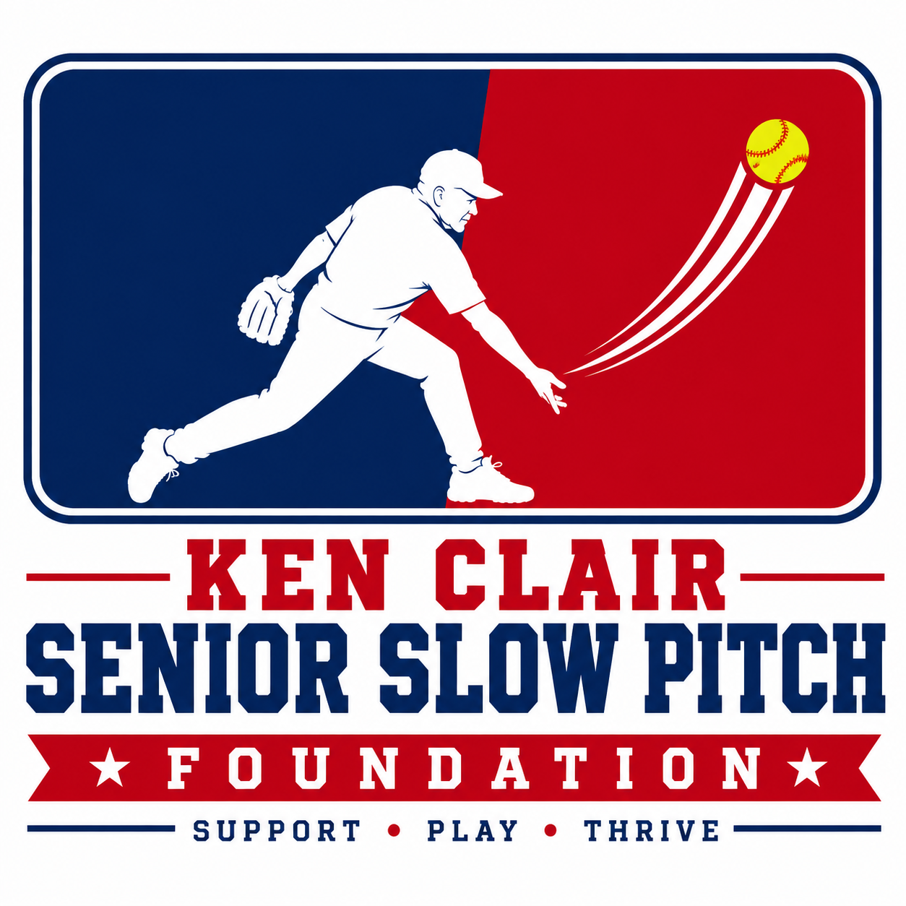
KEN CLAIR
SENIOR SLOW PITCH FOUNDATION
SPONSORSHIP PACKET
HELP US KEEP SENIORS IN THE GAME
Supporting active, healthy and socially connected older adults through senior slow-pitch softball and year-round recreation.
100+ SENIORS • MOVEMENT • FRIENDSHIP • COMMUNITY
Support • Play • Thrive

Our Story
The Ken Clair Senior Slow Pitch Foundation was created by cousins Betty Kraft, Laura Luketich and Stefanie Brydges to help support and grow the senior slow-pitch community connected with Baseball Capital.
What began as a small winter program has grown into a community of more than 100 seniors. During the winter months, players became more than participants - they became teammates and friends. Betty and Kenny stepped in as manager and coach of a senior team that had lost players as well as its previous manager and coach.
Then the story came full circle. We all learned from family members that our grandpa, Ken Clair, had also played and coached in the senior softball program at Clintonwood Park. The Foundation now carries his name and continues that family connection to senior softball.

Our Mission
To encourage active, healthy lifestyles for older adults while fostering sportsmanship, friendship, teamwork and community through the game of softball.

Why This Matters
For many older adults, winter can mean fewer opportunities for meaningful exercise and social connection. Senior slow pitch gives participants a reason to get moving, a place to belong and something to look forward to.
“Being with other seniors having fun, challenging our strengths and weaknesses ... has increased my mobility and mental stamina.”
— John Begovich, senior program participant, age 69

More Than Softball: A Year-Round Senior Community
The Foundation helps make it possible to offer seniors affordable ways to move, connect and stay engaged. Our current senior programming at Baseball Capital includes both slow pitch and a new fitness option designed specifically for older adults.
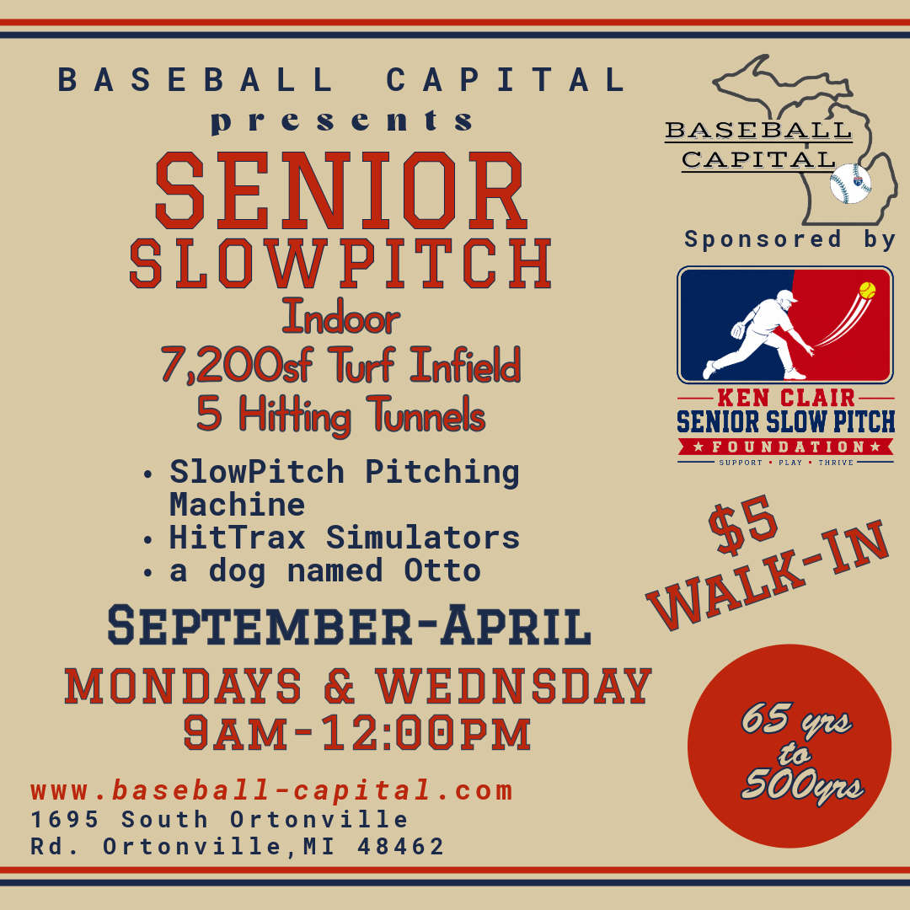  SENIOR SLOW PITCH  $5 walk-in  Mondays & Wednesdays • 9:00 AM-12:00 PM  September-April • Indoor at Baseball Capital  Players have access to 7,200 sq. ft. of turf, five hitting tunnels, HitTrax simulators and a slow-pitch pitching machine. The heart of the program is simple: keep seniors moving and keep them together. | 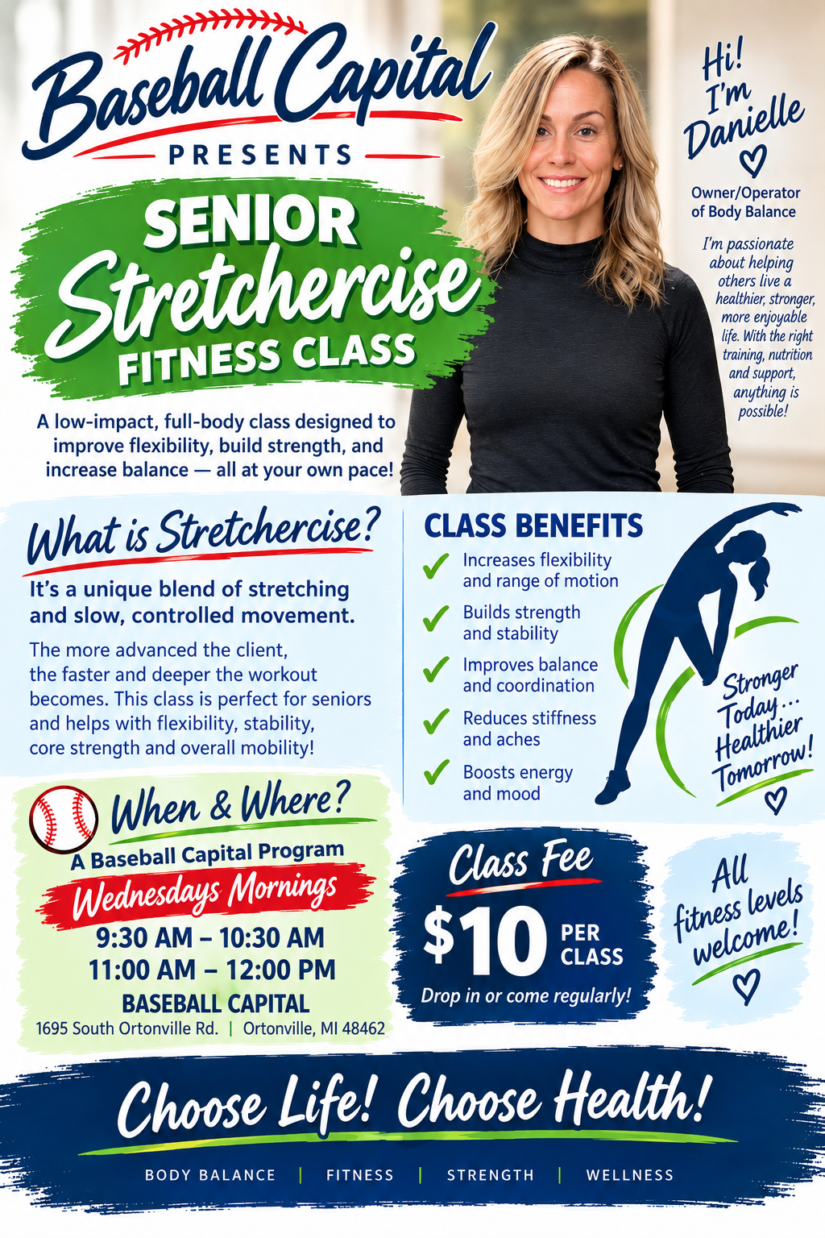  SENIOR STRETCHERCISE  $10 per class  Wednesday mornings • 9:30-10:30 AM & 11:00 AM-12:00 PM  Led by Danielle of Body Balance  This low-impact, full-body class blends stretching with slow, controlled movement to support flexibility, strength, balance, coordination and overall mobility. All fitness levels are welcome.
SPONSORSHIP HELPS US KEEP THESE OPPORTUNITIES AFFORDABLE, SAFE AND GROWING.

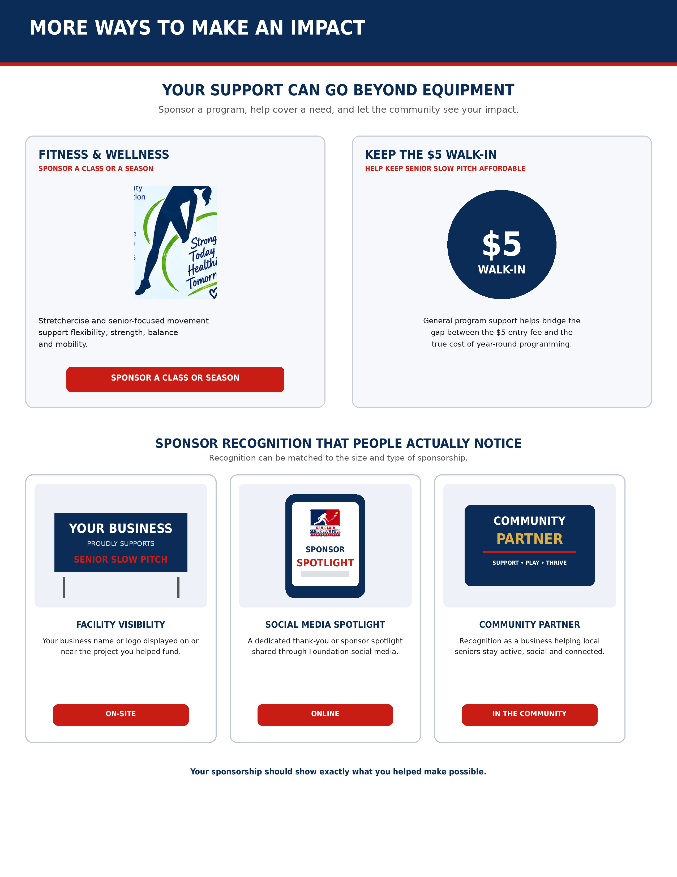

Sponsorship & Donation Commitment
Thank you for helping us keep seniors active, social, safe and in the game.
Business / Sponsor Name: _________________________________________________
Contact Name: ___________________________________________________________
Phone: ______________________________ Email: _____________________________
Address: _________________________________________________________________
City / State / ZIP: _______________________________________________________
I / We would like to support:
☐ Community Champion
☐ Equipment Sponsor
☐ Senior Program Sponsor
☐ Team Sponsor
☐ Event Sponsor
☐ Sponsor What You Can
Sponsorship / Donation Amount: $____________________________
Notes or preferred use of gift: ____________________________________________
__________________________________________________________________________

Foundation Information
Legal Name | KEN CLAIR SENIOR SLOW PITCH FOUNDATION
Status | 501(c)(3) Nonprofit Organization
EIN / Tax ID | KENC 61-233214
Michigan Entity ID | 900160568
Articles of Incorporation Filed | February 6, 2026

Founding Board of Directors
Betty Kraft — President
Laura Luketich — Secretary
Stefanie Brydges — Treasurer
Thank you for supporting seniors in our community.

